# FRONTEND REPORT

# comlist

DataTable: Company

Navigation: Staff Page

Authorization: Staff

Linked Features: List of Medicine’s Company

# comadd

DataTable: Company

Navigation: Staff Page

Authorization: Staff

Linked Features: Add Medicine’s Company

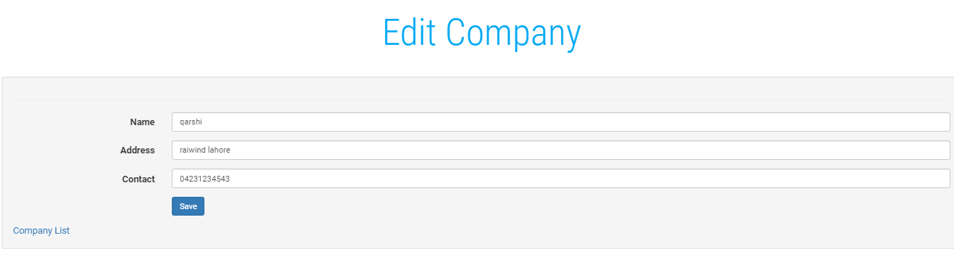

DataTable: Company

Navigation: Staff Page

Authorization: Staff

Linked Features: Medicine’s Company

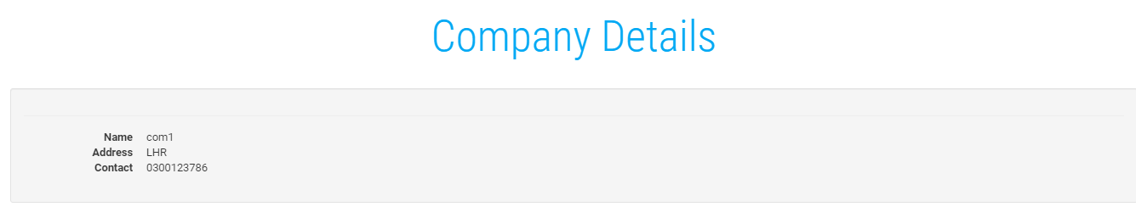

DataTable: Company

Navigation: Staff Page

Authorization: Staff

Linked Features: Detail Medicine’s Company

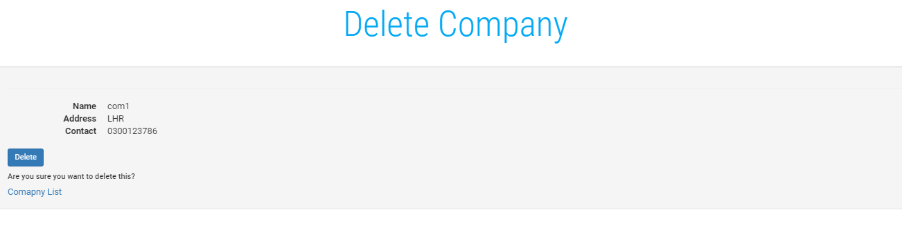

DataTable: Company

Navigation: Staff Page

Authorization: Staff

Linked Features: Delete Medicine’s Company

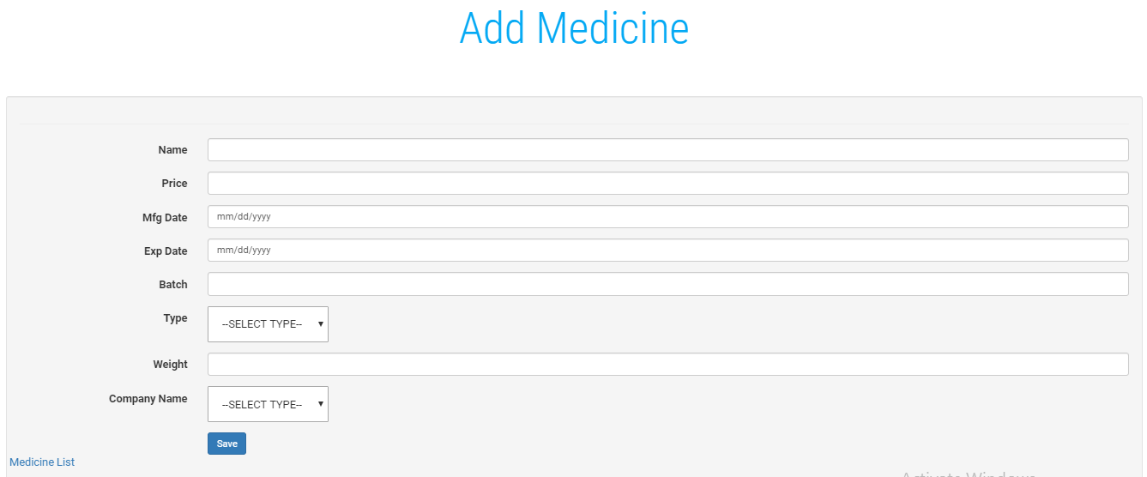

DataTable: Medicine

Navigation: Staff Page

Authorization: Staff

Linked Features: Add Medicine

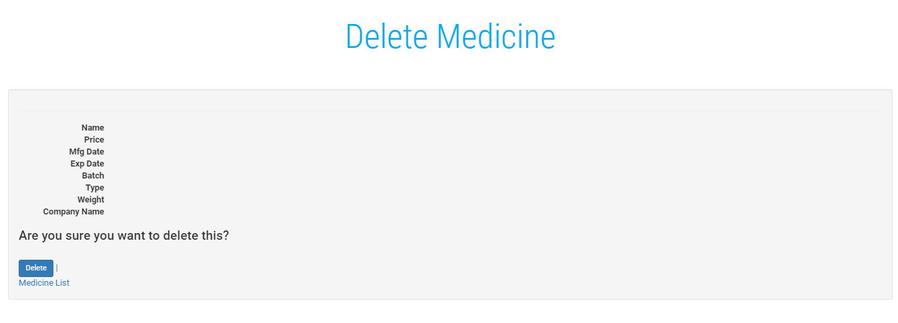

DataTable: Company

Navigation: Staff Page

Authorization: Staff

Linked Features: Delete Medicine

# Feature List

1. Staff Information report.
2. Staff salaries report.
3. Medicine name and ID information report.
4. Medicine name and company name report from which medicine belong.
5. Medicine name and price, type report.
6. Company name and ID report.
7. Stock information report.
8. Details of the inventory report.
9. Details of Sold product report.
10. Daily, weekly or monthly report of sales.

# Complete Feature

* Staff Information .
* Staff salaries report.
* Medicine information by 2016-CS-154.
* Medicine’s company name from which medicine belong by 2016-CS-154.
* Medicine name and price, type by 2016-CS-154.
* Company information by 2016-CS-154.

**2016CS170**

**ADD Customer:**



DataTable: Customer

Navigation: Customer

Authorization: Customer

Linked Features: Customer

**Index page of Customer:**

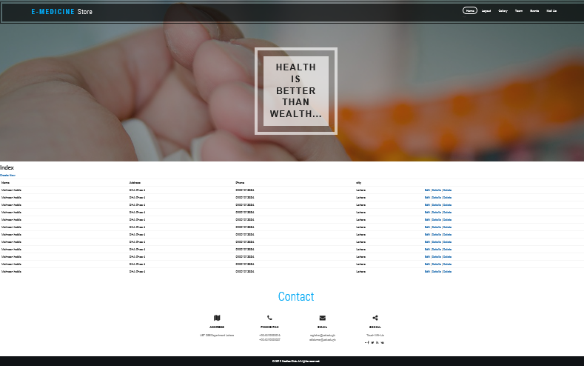

DataTable: Customer

Navigation: Customer

Authorization: Customer

Linked Features: Customer

**Edit Page of customer:**



DataTable: Customer

Navigation: Customer

Authorization: Customer

Linked Features: Customer

**Add Order:**

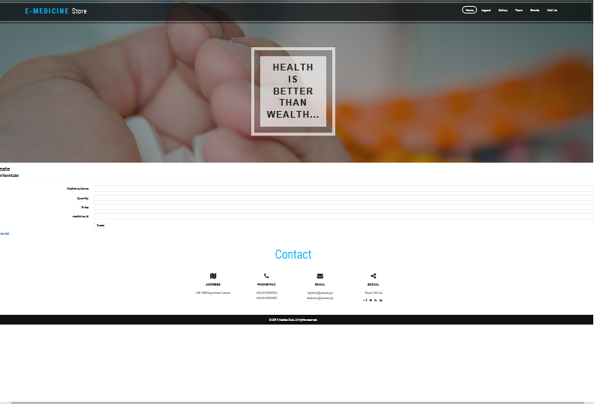

DataTable: Order

Navigation: Medicine, Bill

Authorization: Customer

Linked Features: Medicine, Bill

**Index of Order:**

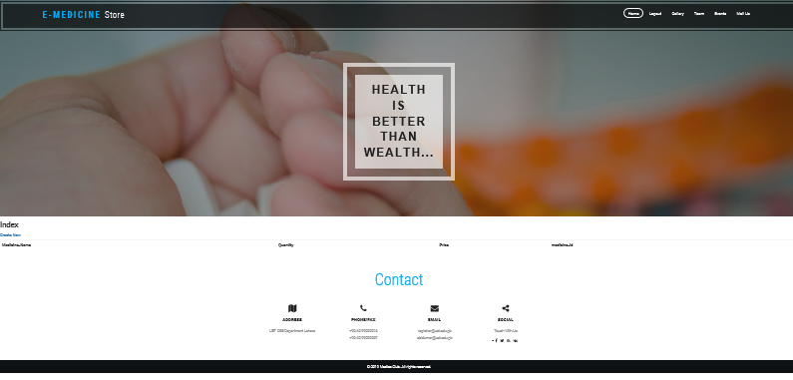

DataTable: Order

Navigation: Medicine, Bill

Authorization: Customer

Linked Features: Medicine, Bill

**Create Bill:**



DataTable: Bill

Navigation: Order

Authorization: Staff

Linked Features: Order

**Index of Bill:**



DataTable: Bill

Navigation: Order

Authorization: Staff

Linked Features: Order